|  |
| --- |
|  |
| Police Station |
| IT 214 -001 |

|  |
| --- |
| Joel Mondal |

**Crows foot diagram**



Screen shots of the queries used to create tables and populate them with data. For each table, include the following:

a. A screen shot(s) of the SQL query you used to create the table with appropriate attributes and data types together with primary keys, foreign keys, relationships and constraints.

**POLICEMAN:**

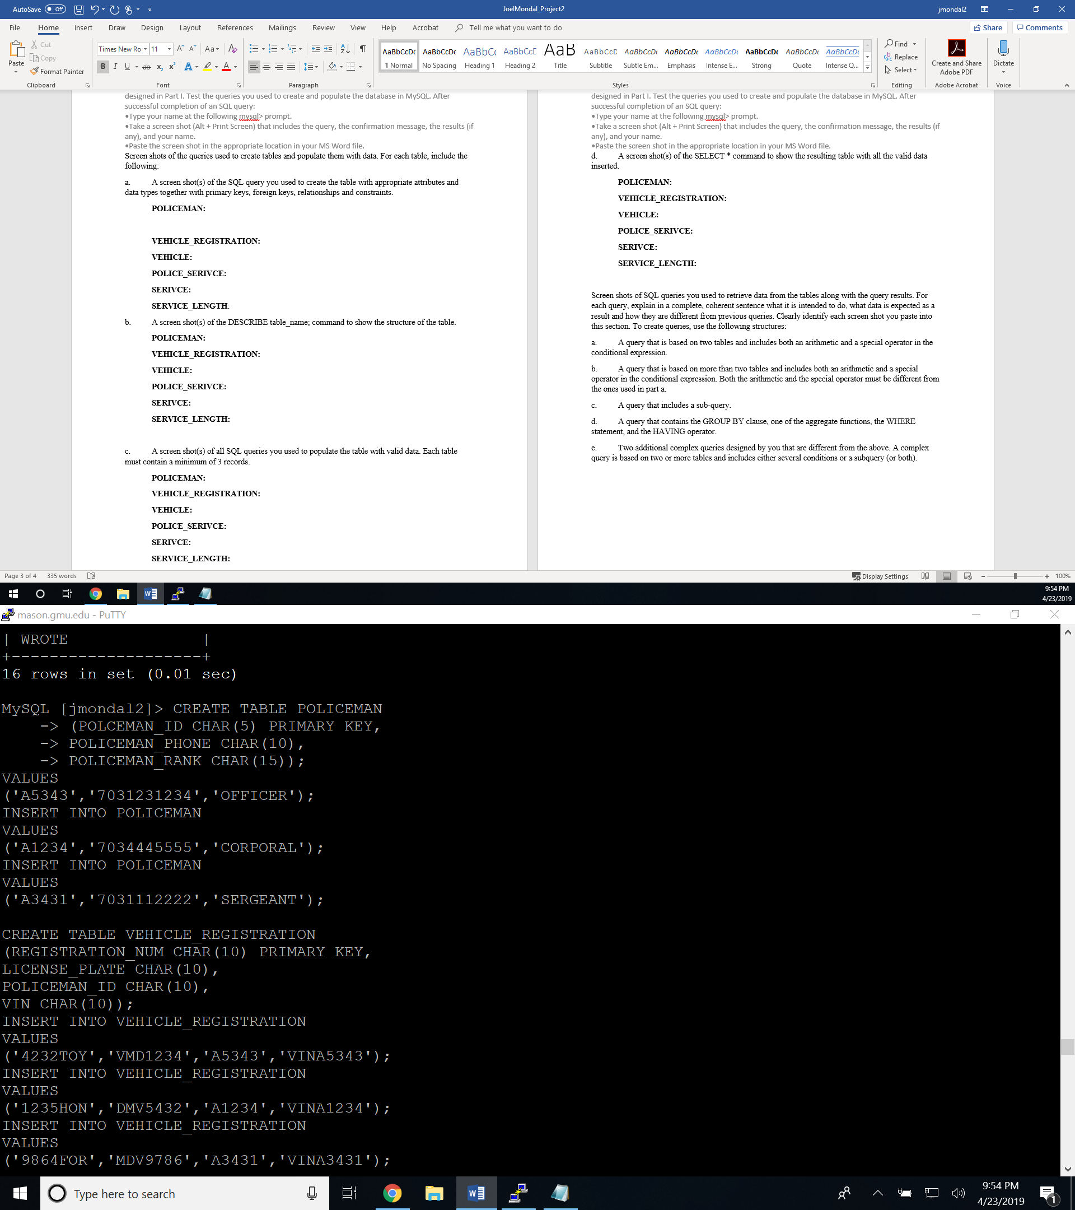

**VEHICLE_REGISTRATION:**

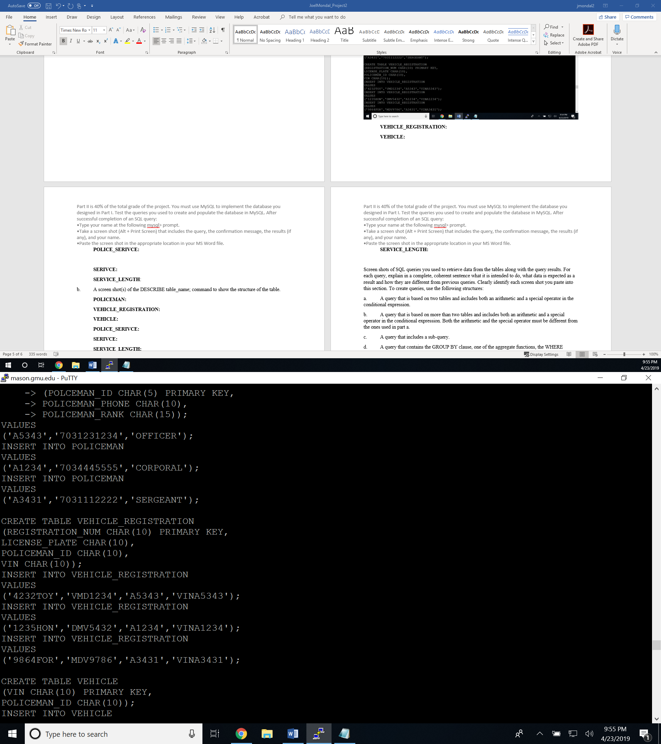

**VEHICLE:**

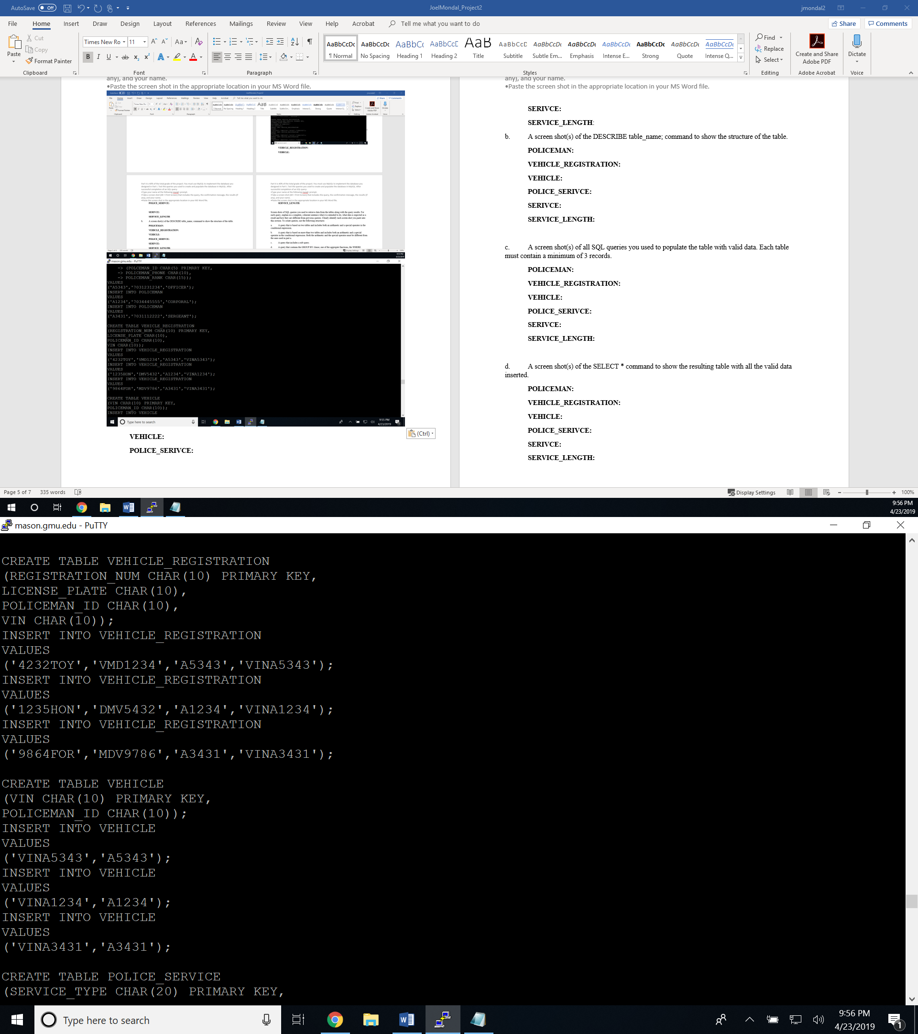

**POLICE_SERIVCE:**

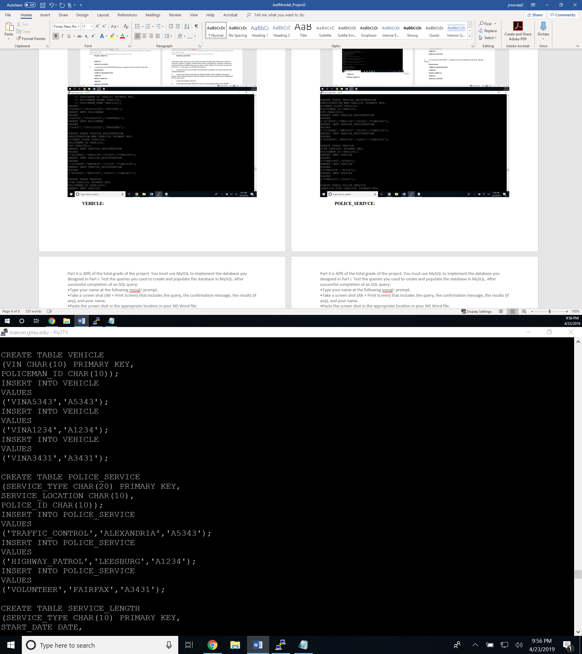

**SERIVCE:**

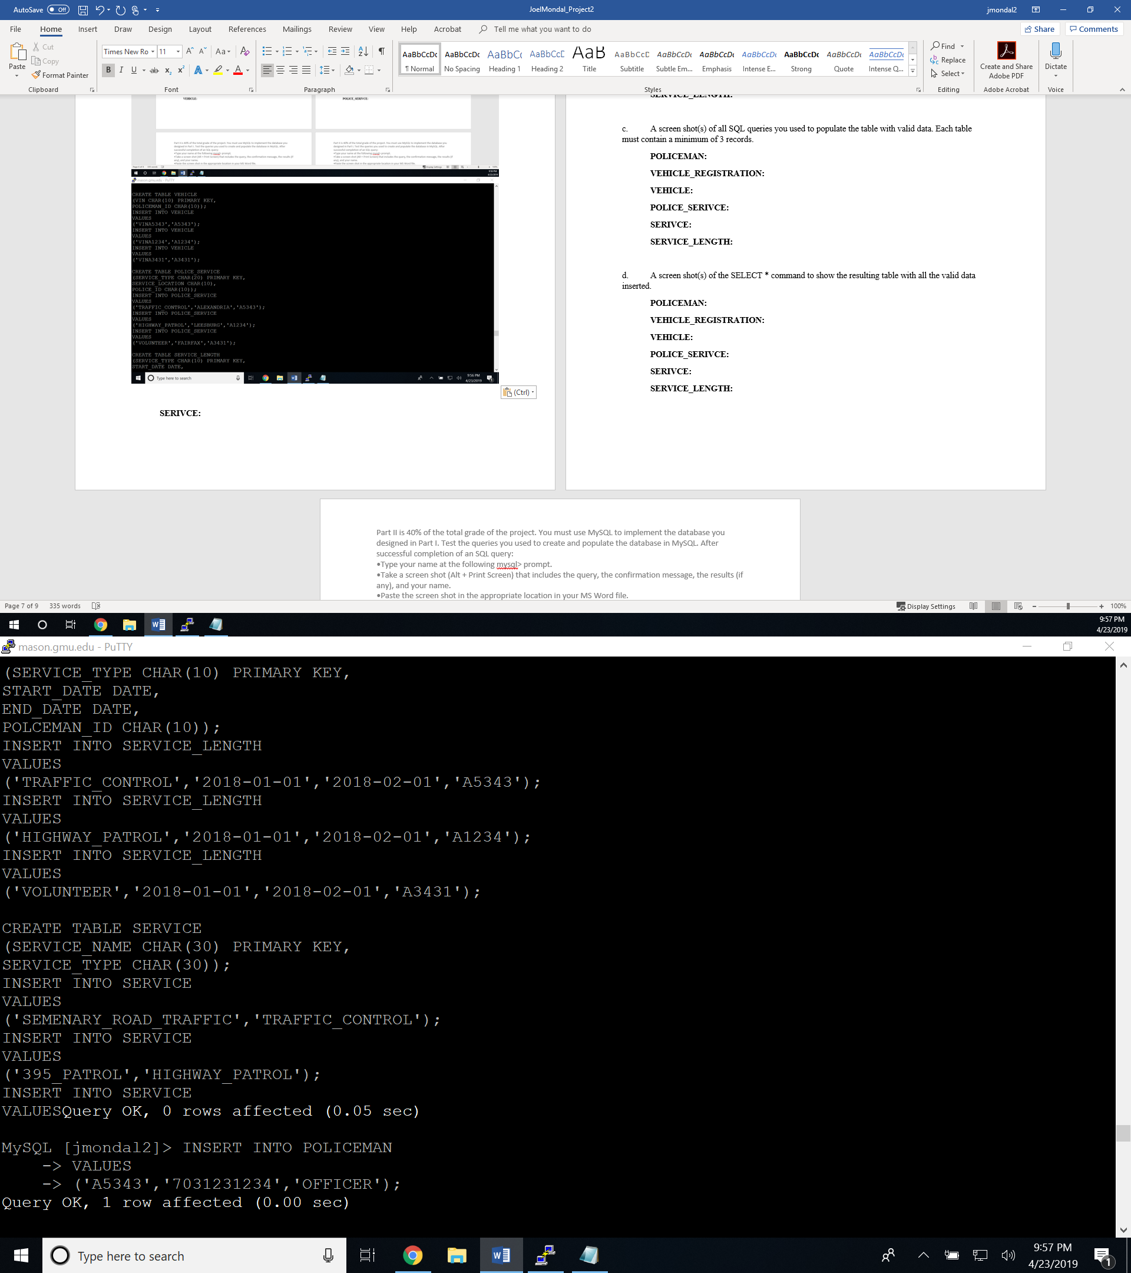

**SERVICE_LENGTH**:

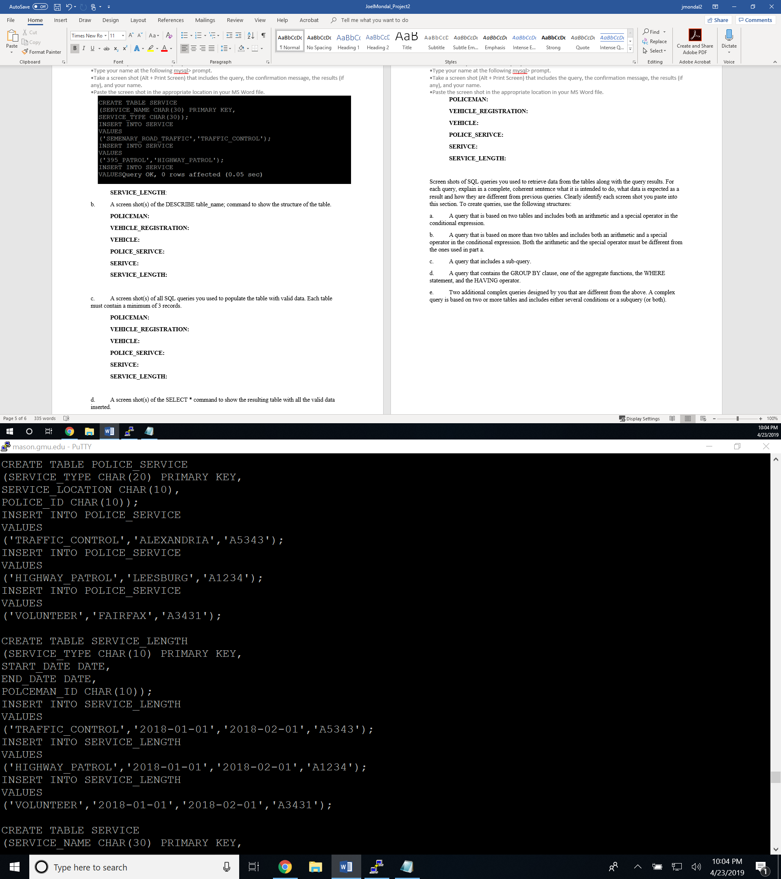

b. A screen shot(s) of the DESCRIBE table_name; command to show the structure of the table.

**POLICEMAN:**

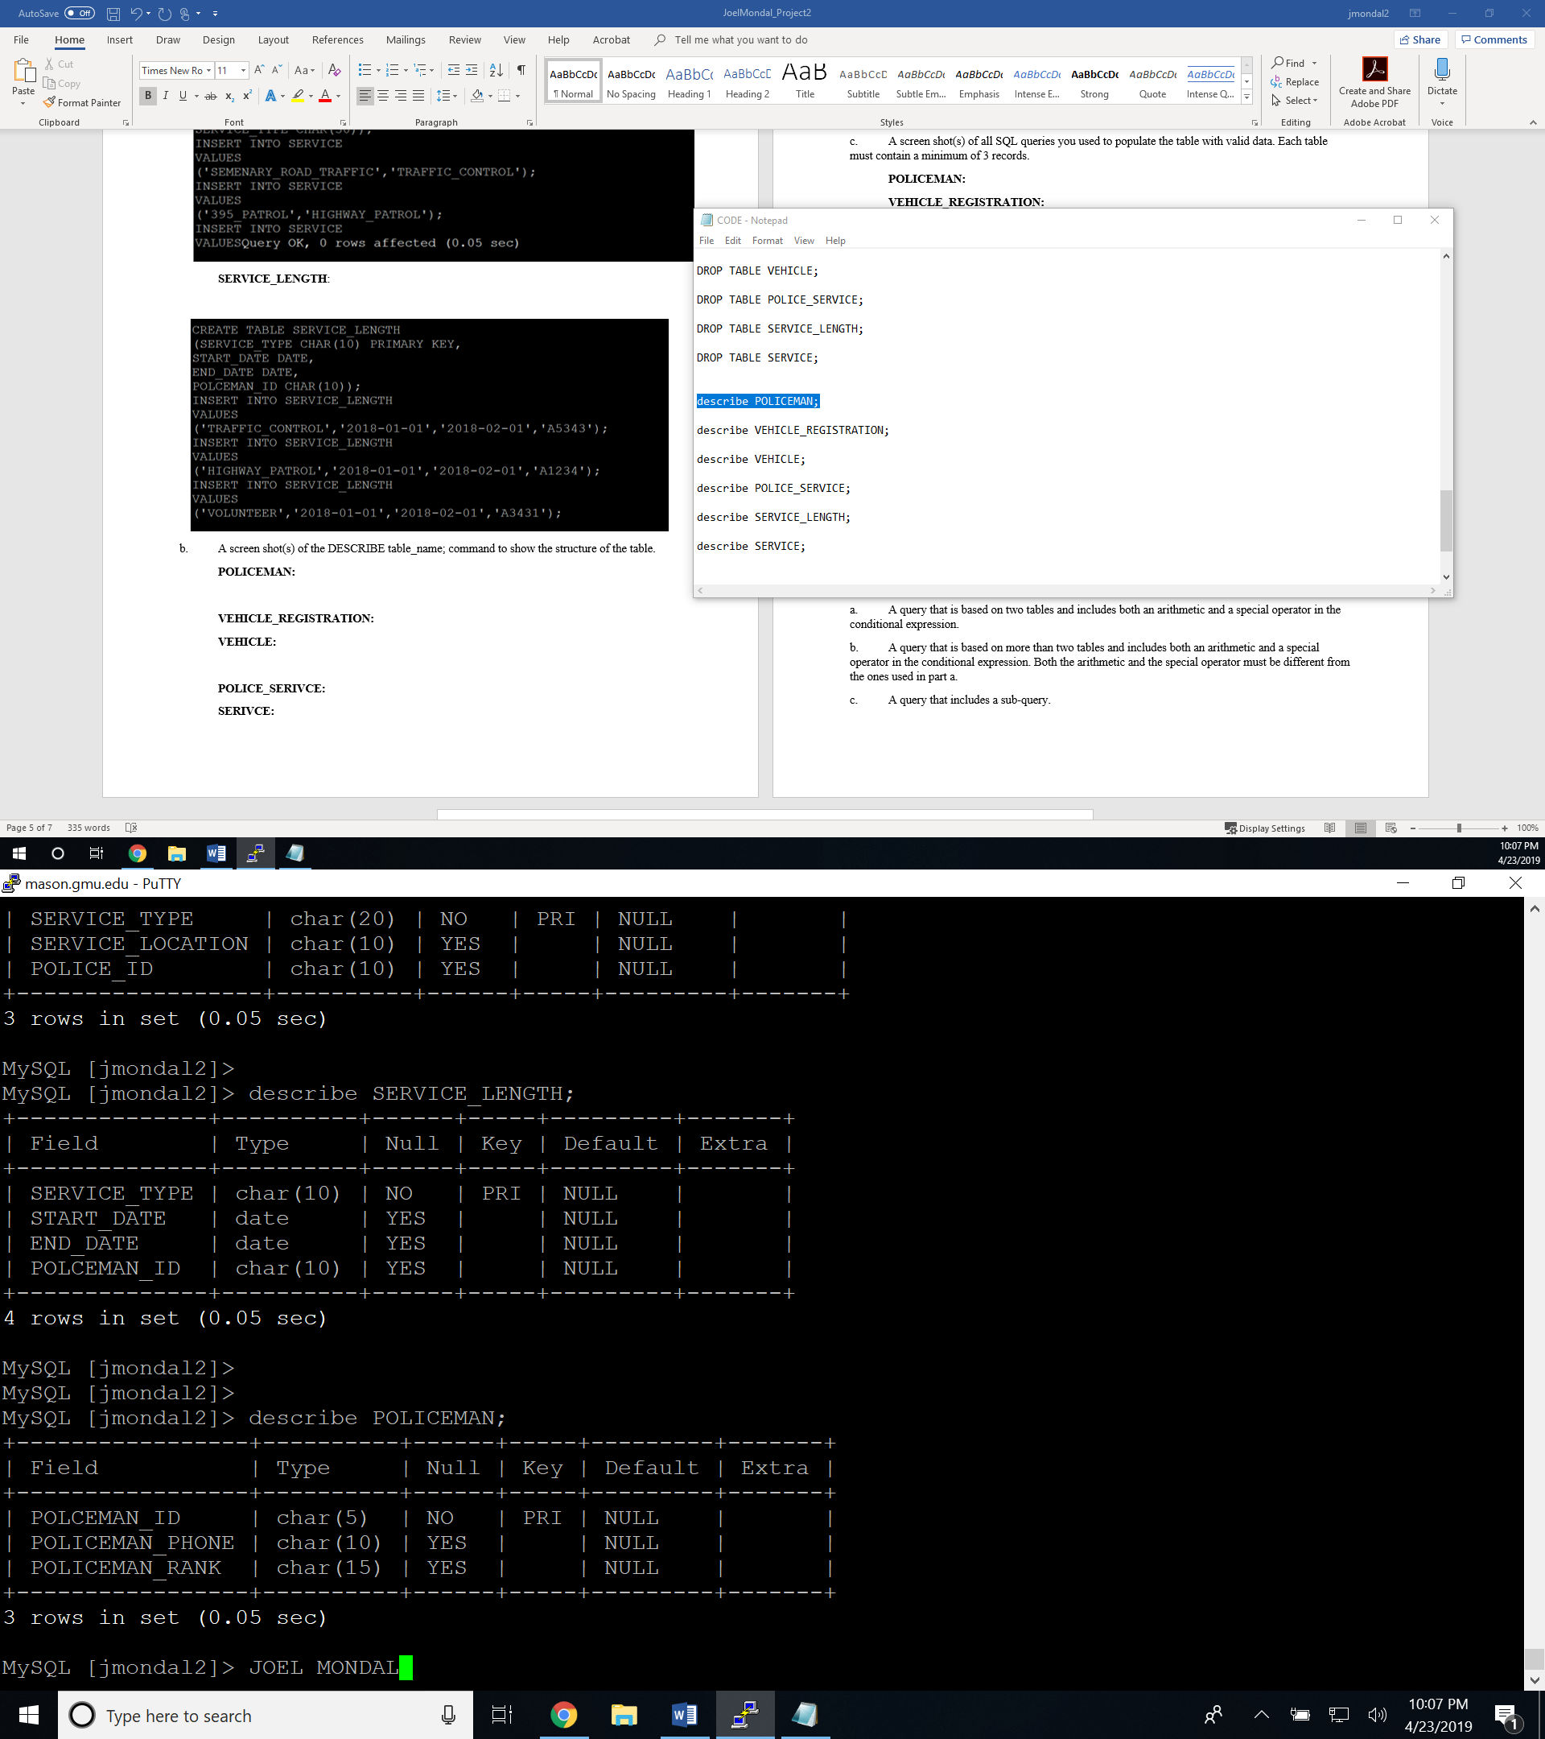

**VEHICLE_REGISTRATION:**

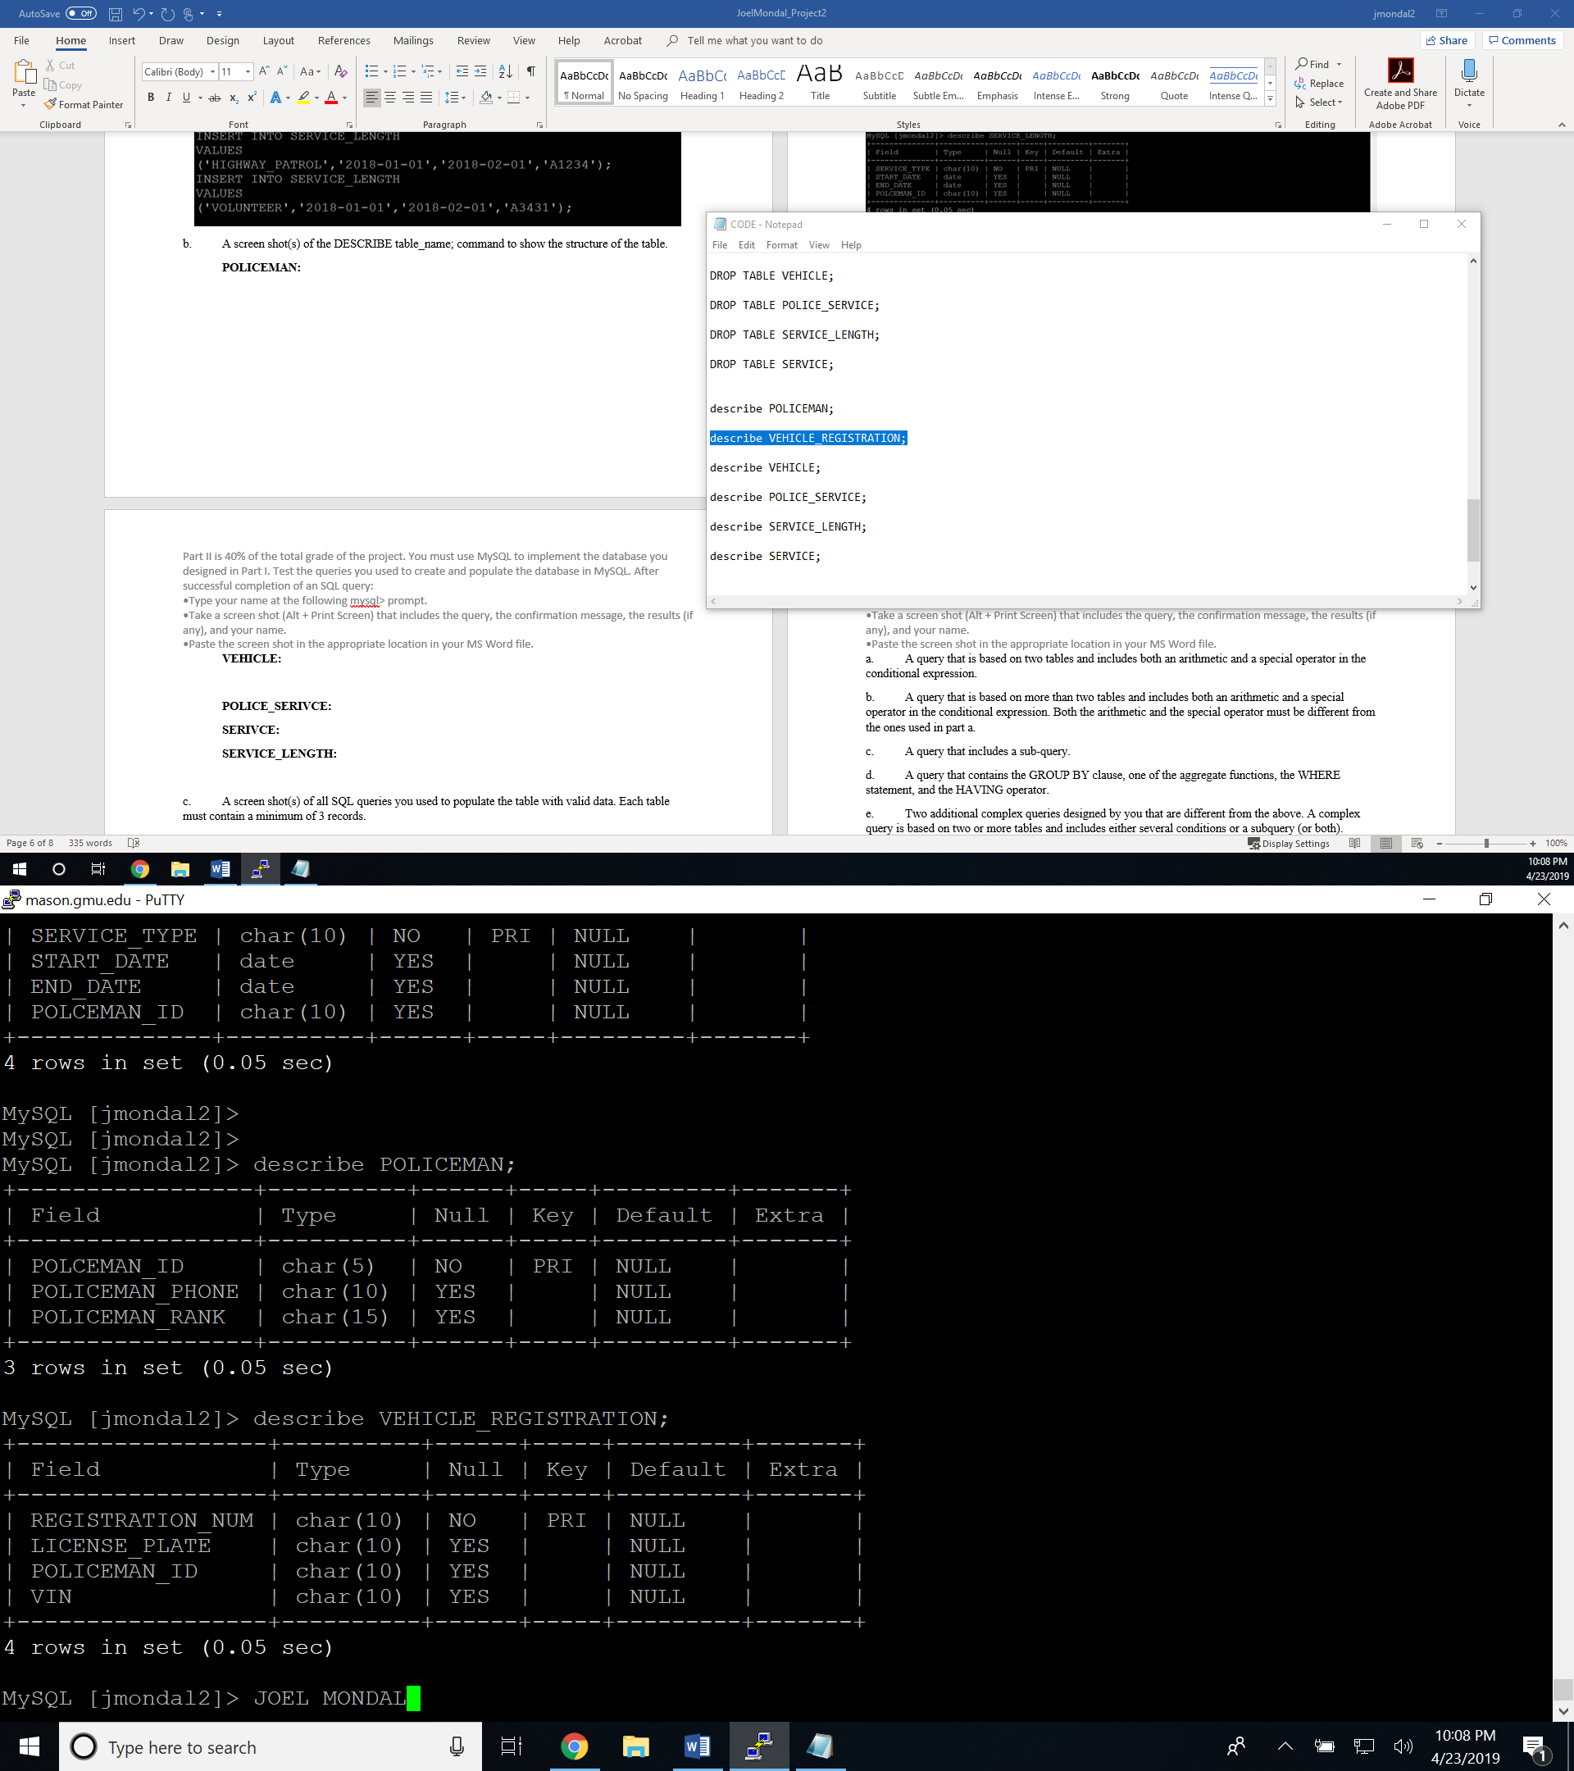

**VEHICLE:**

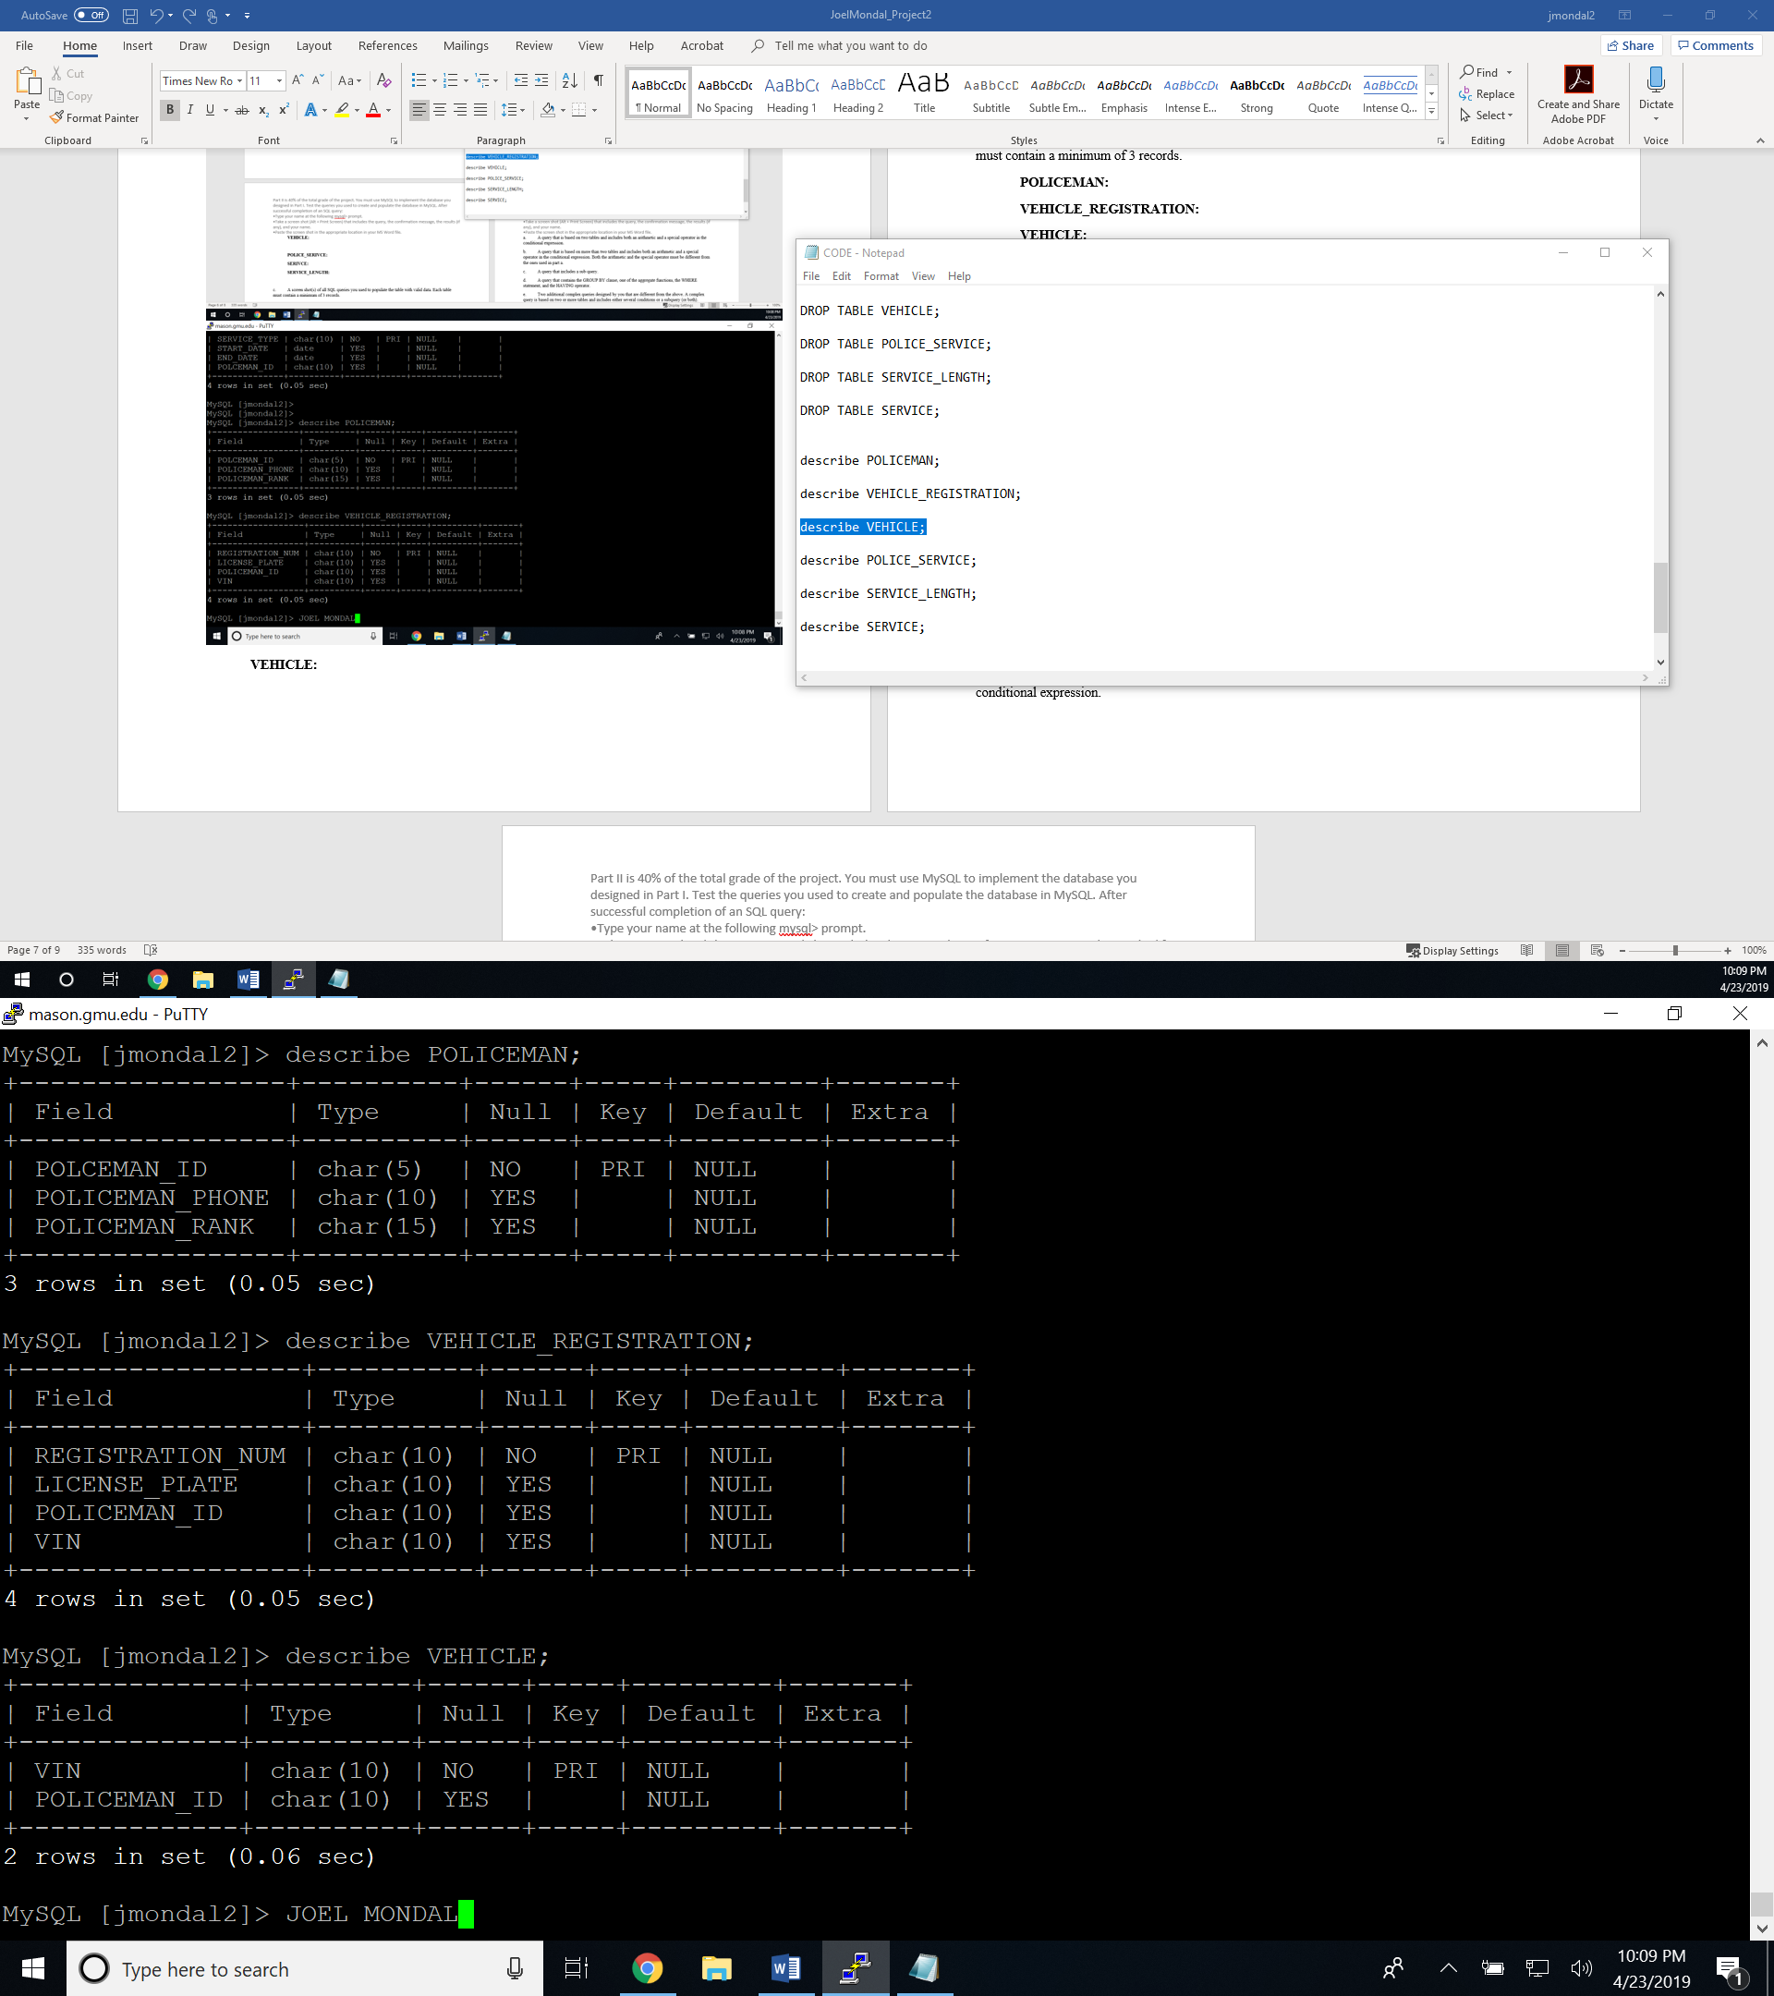

**POLICE_SERIVCE:**

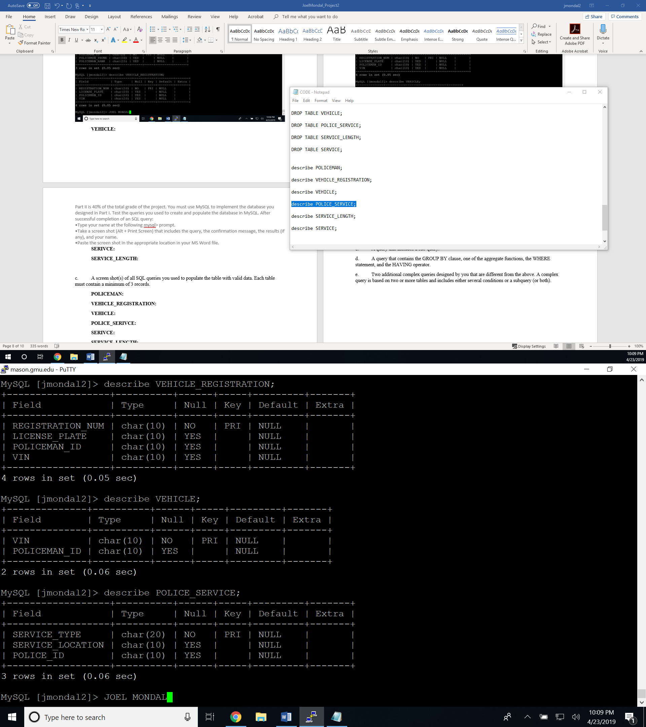

**SERIVCE:**

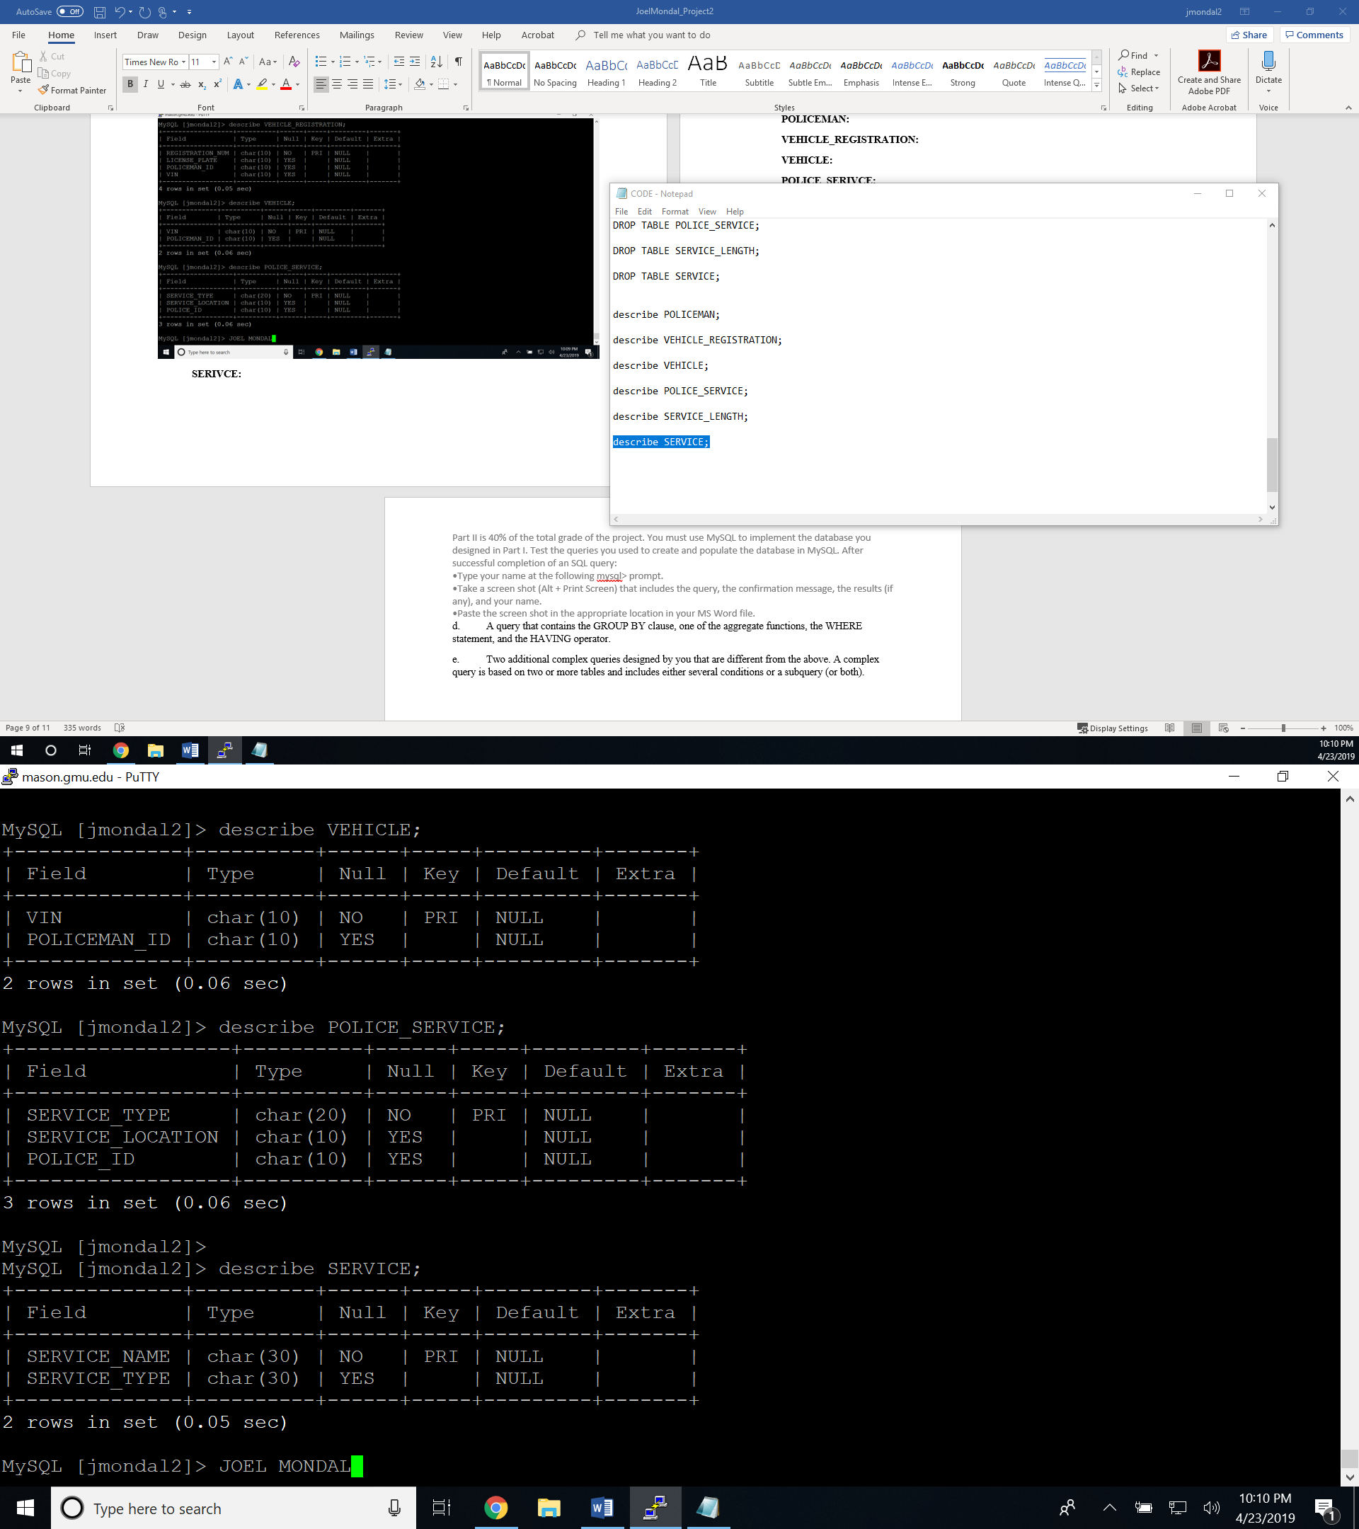

**SERVICE_LENGTH:**

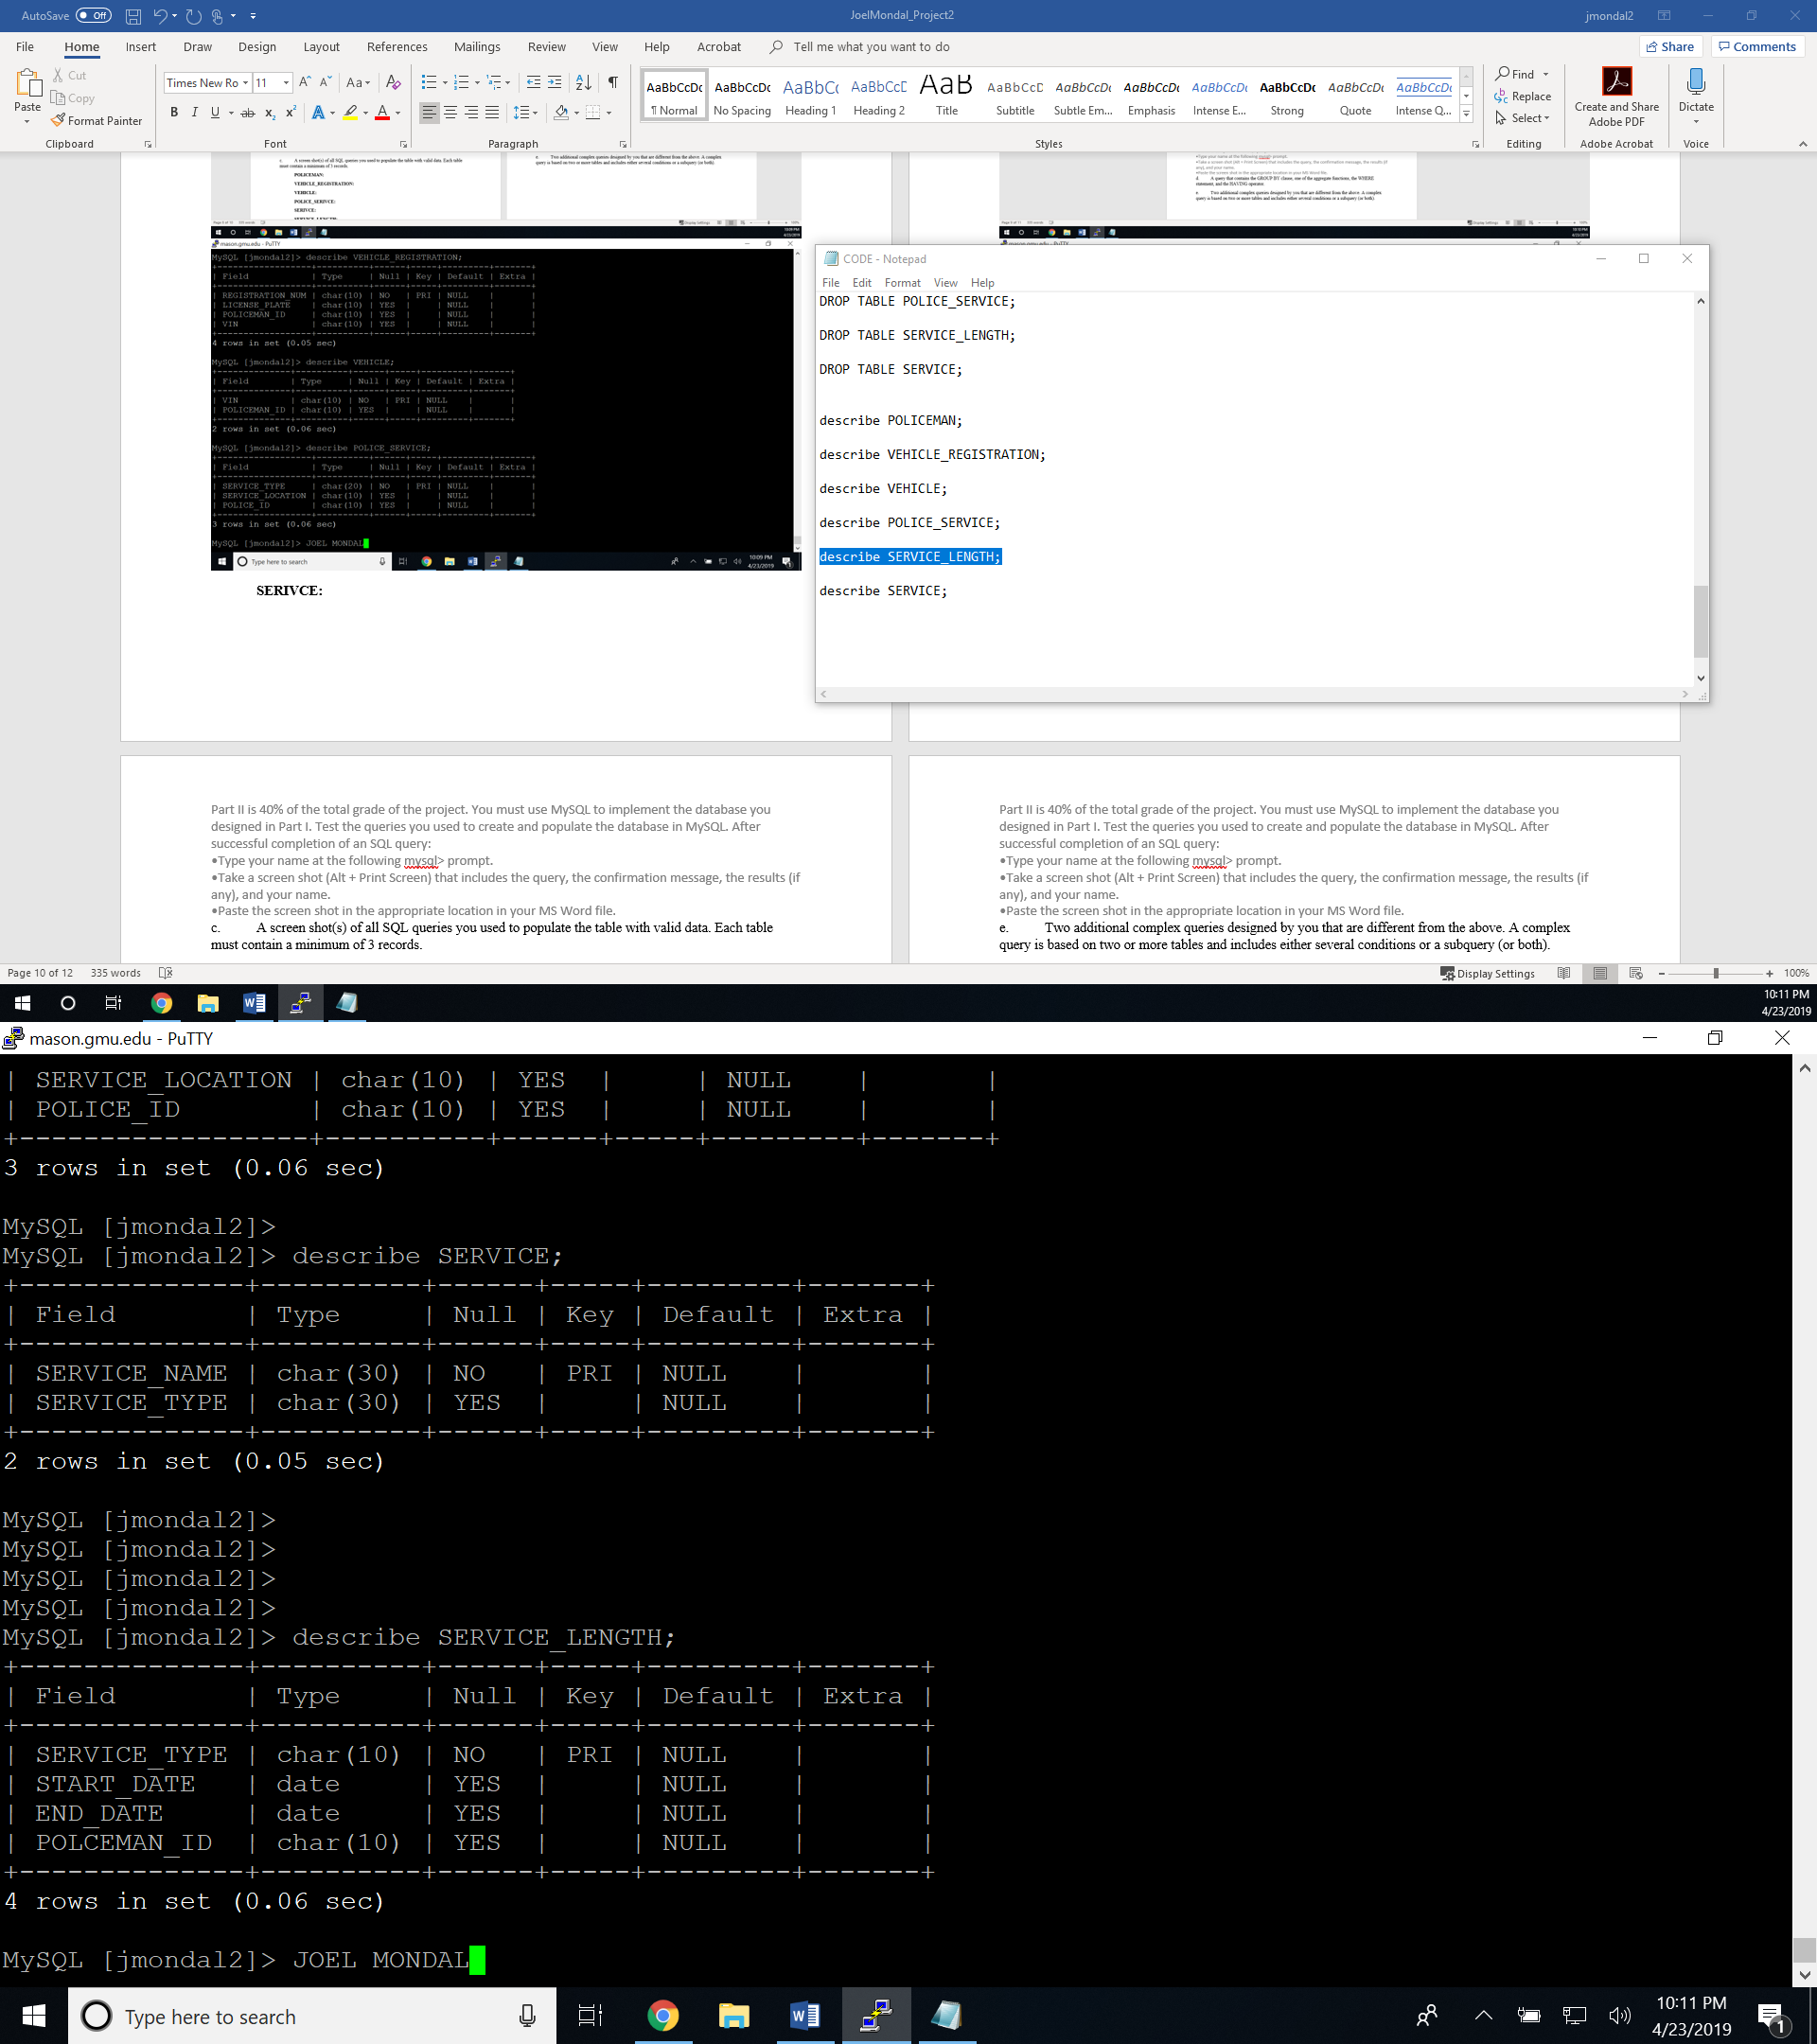

c. A screen shot(s) of all SQL queries you used to populate the table with valid data. Each table must contain a minimum of 3 records.

**I CREATED THE TABLES AND POPULATED THE DATA AT THE SAME TIME THEREFORE, I USED THE SAME PICTURES AS SEEN IN PART A.**

**POLICEMAN:**



**VEHICLE_REGISTRATION:**



**VEHICLE:**



**POLICE_SERIVCE:**



**SERIVCE:**



**SERVICE_LENGTH:**



d. A screen shot(s) of the SELECT * command to show the resulting table with all the valid data inserted.

**POLICEMAN:**

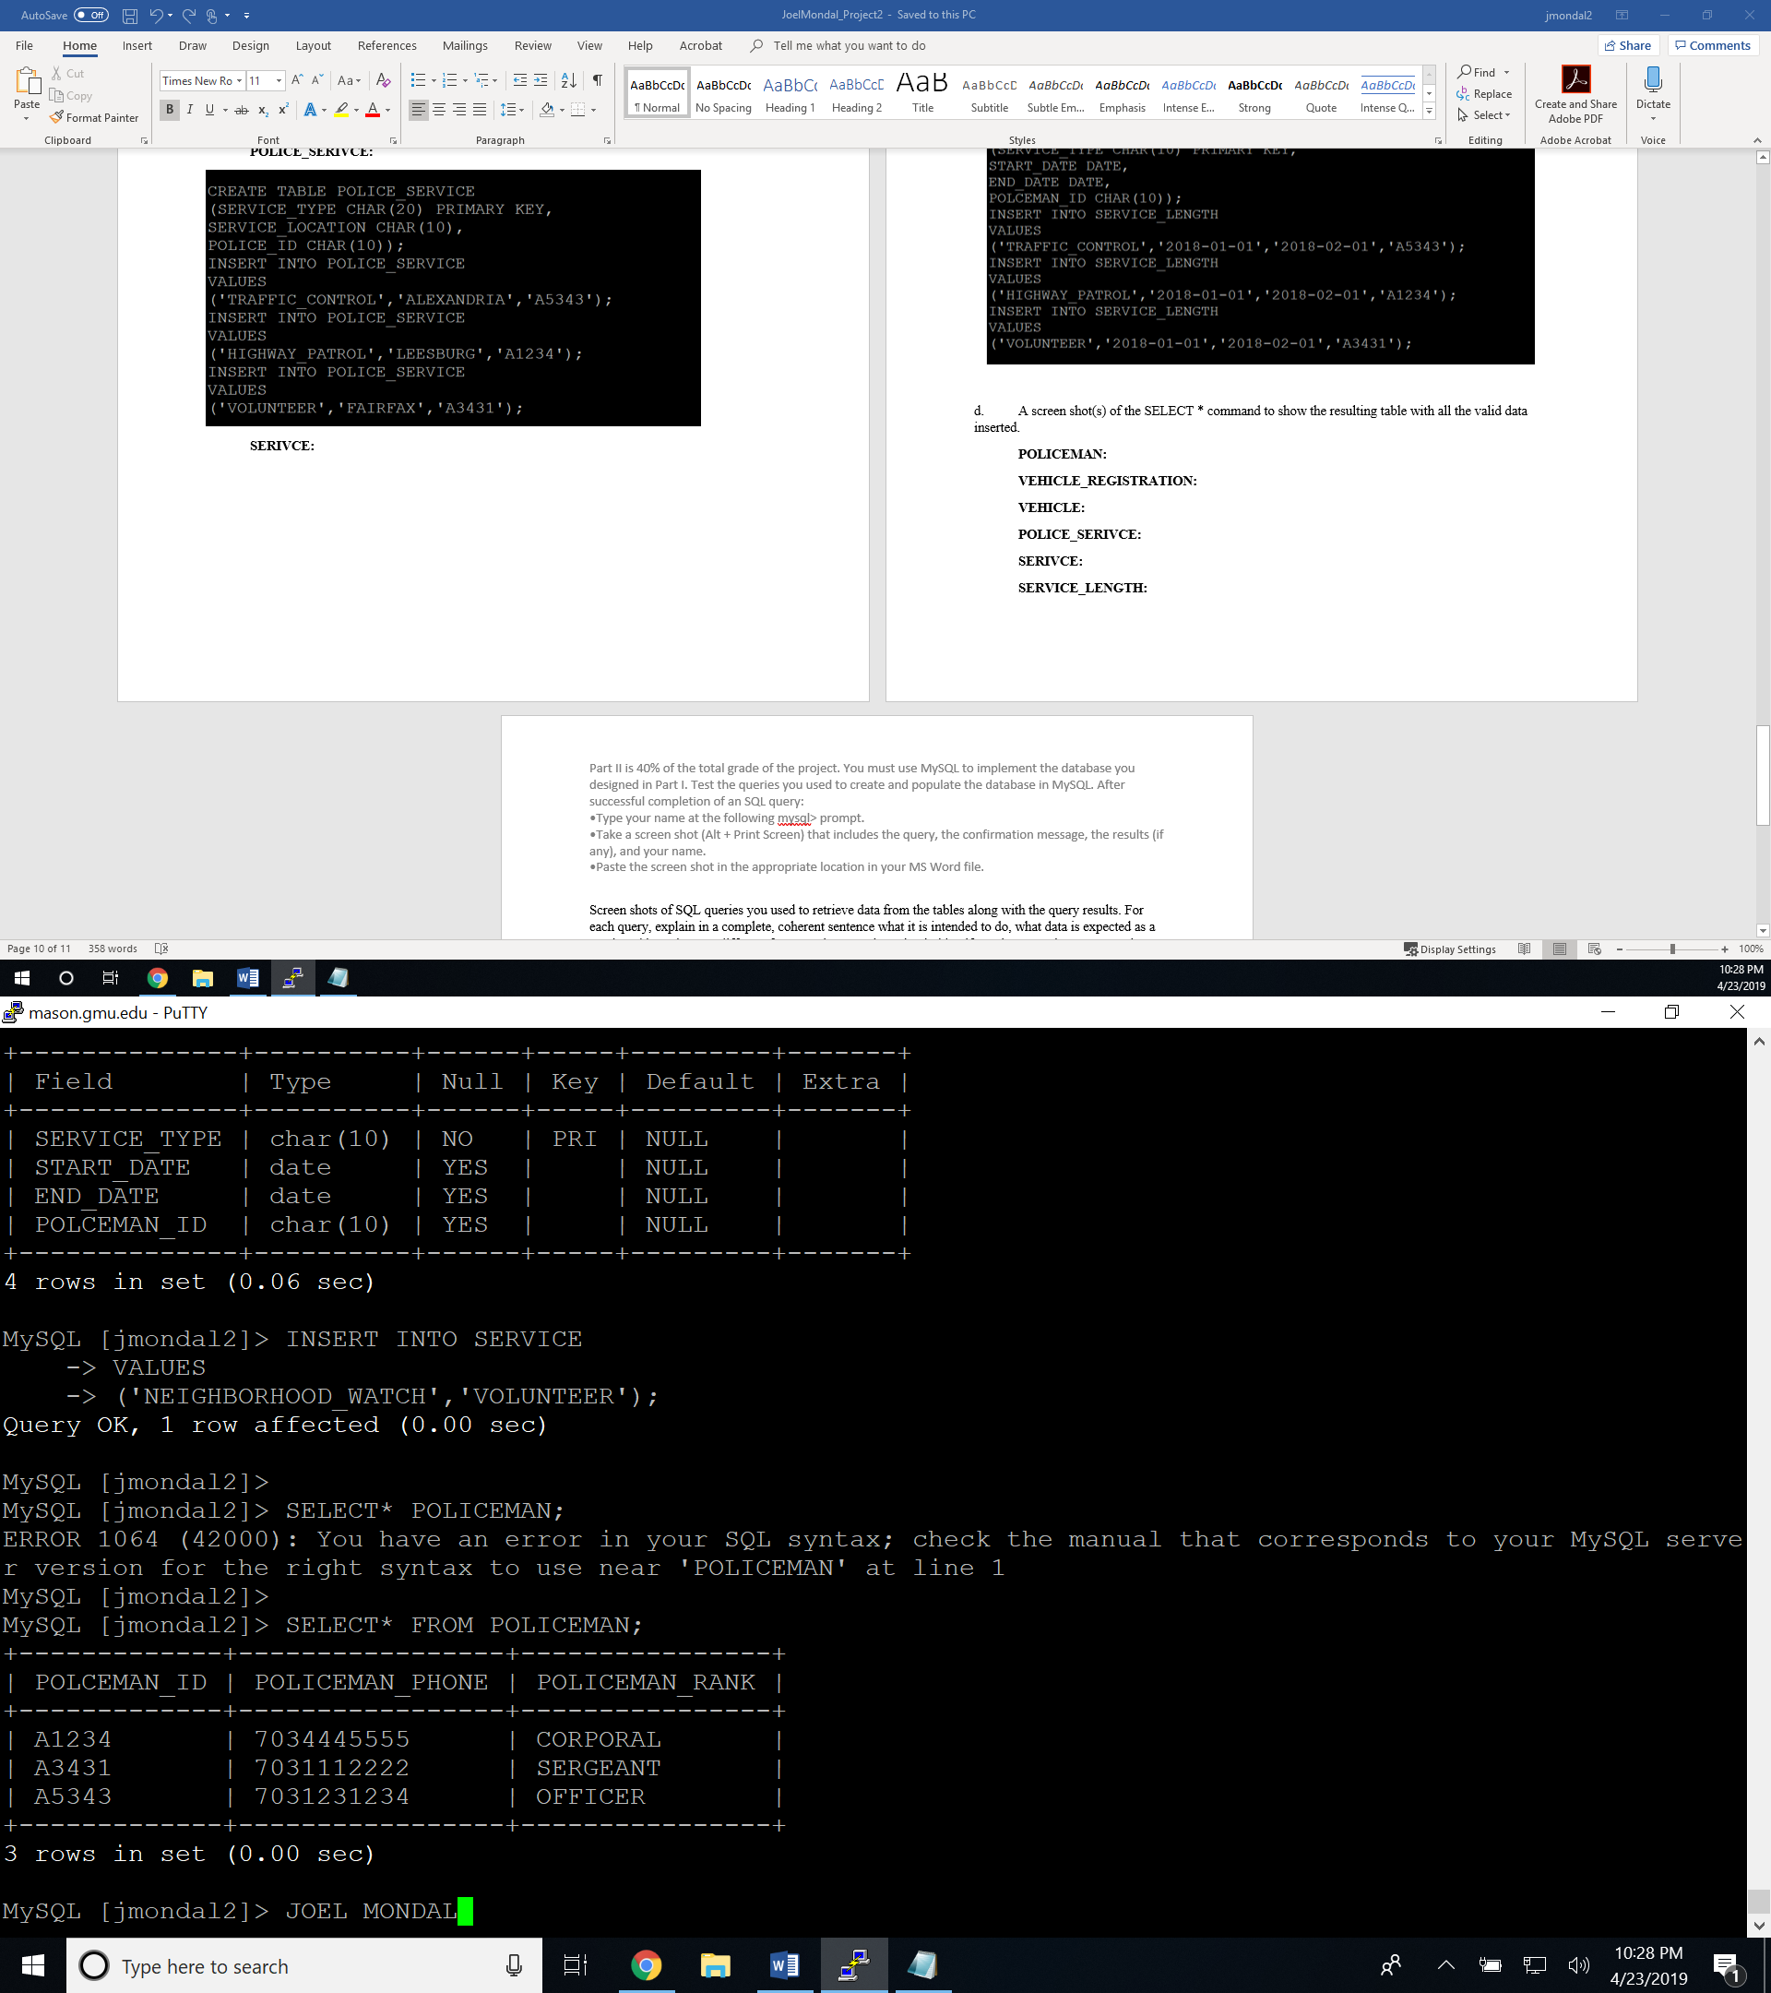

**VEHICLE_REGISTRATION:**

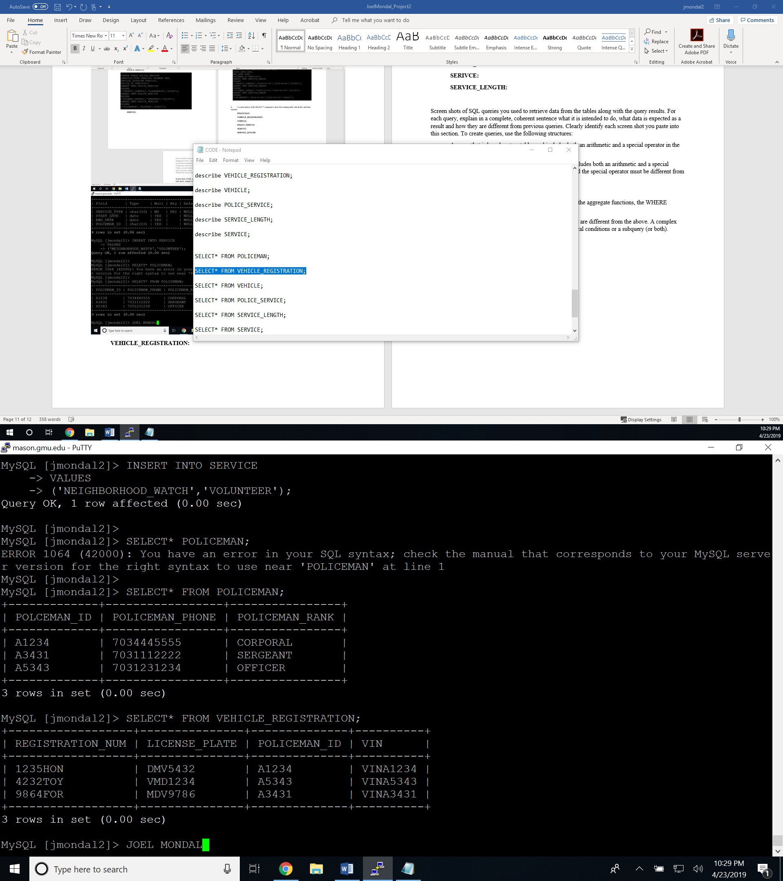

**VEHICLE:**

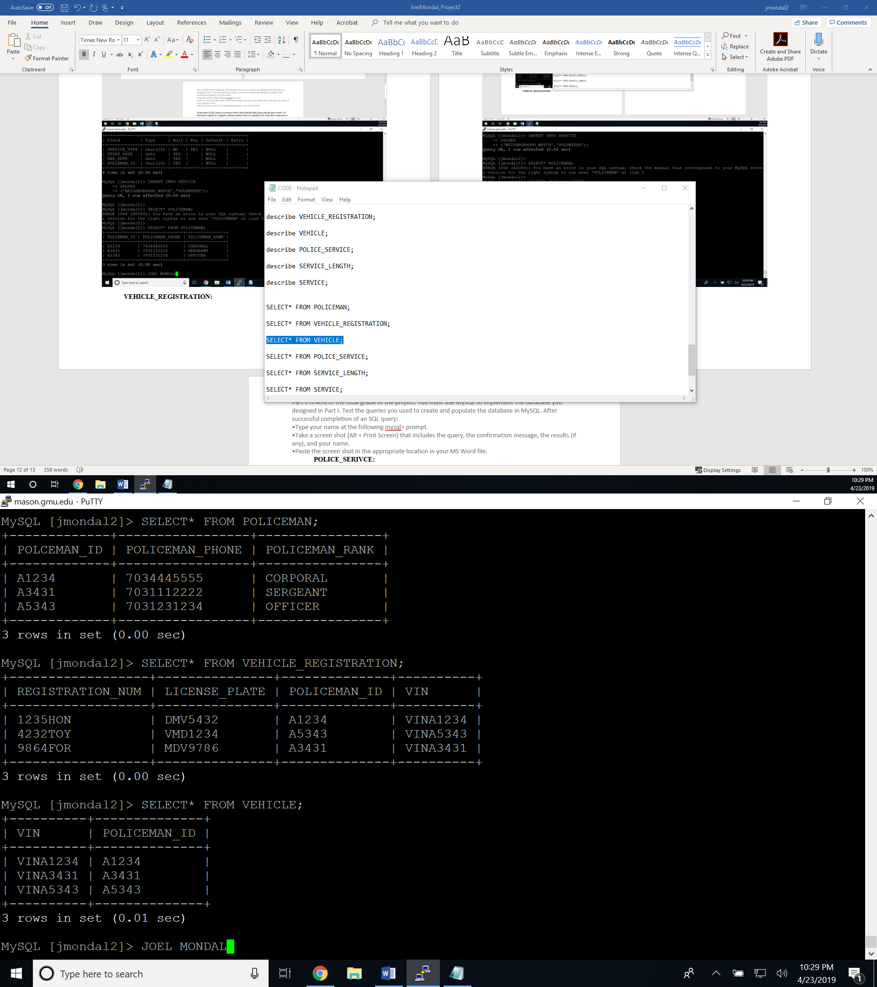

**POLICE_SERIVCE:**

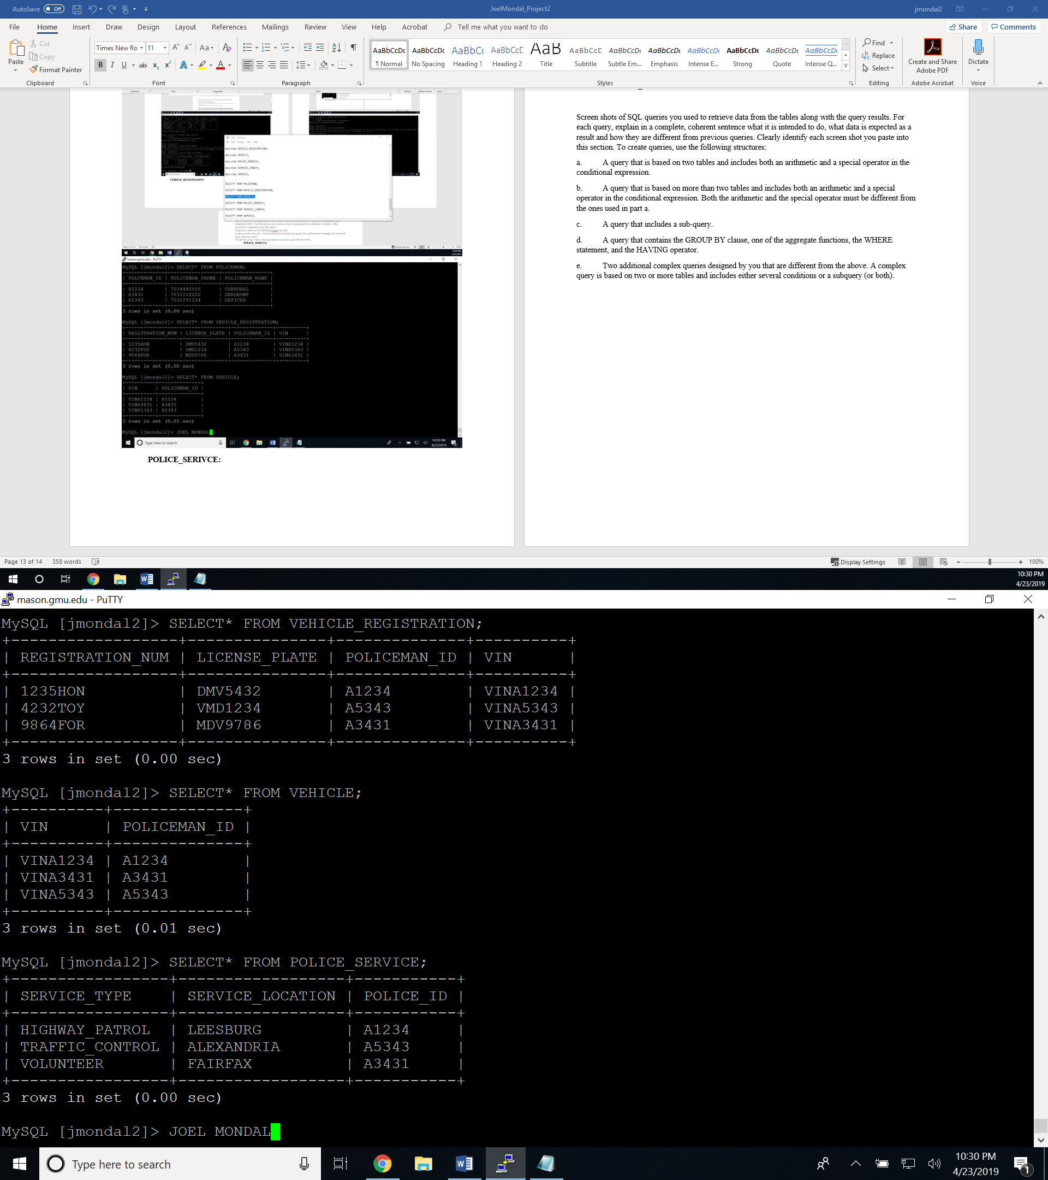

**SERIVCE:**

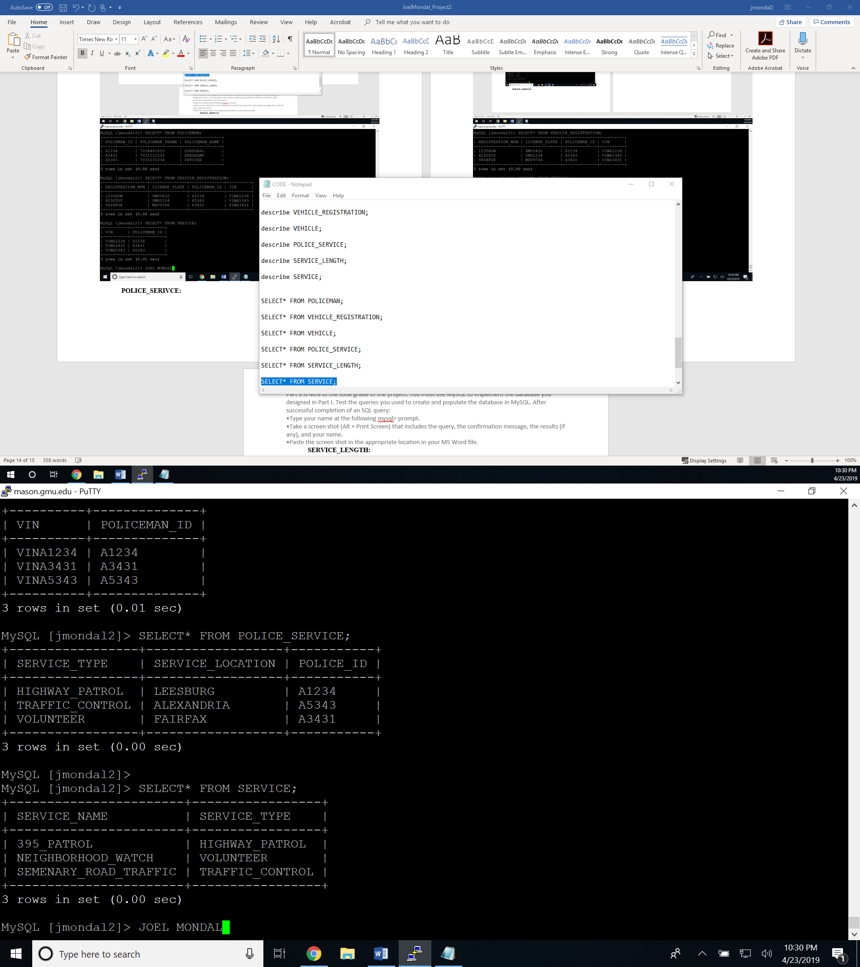

**SERVICE_LENGTH:**

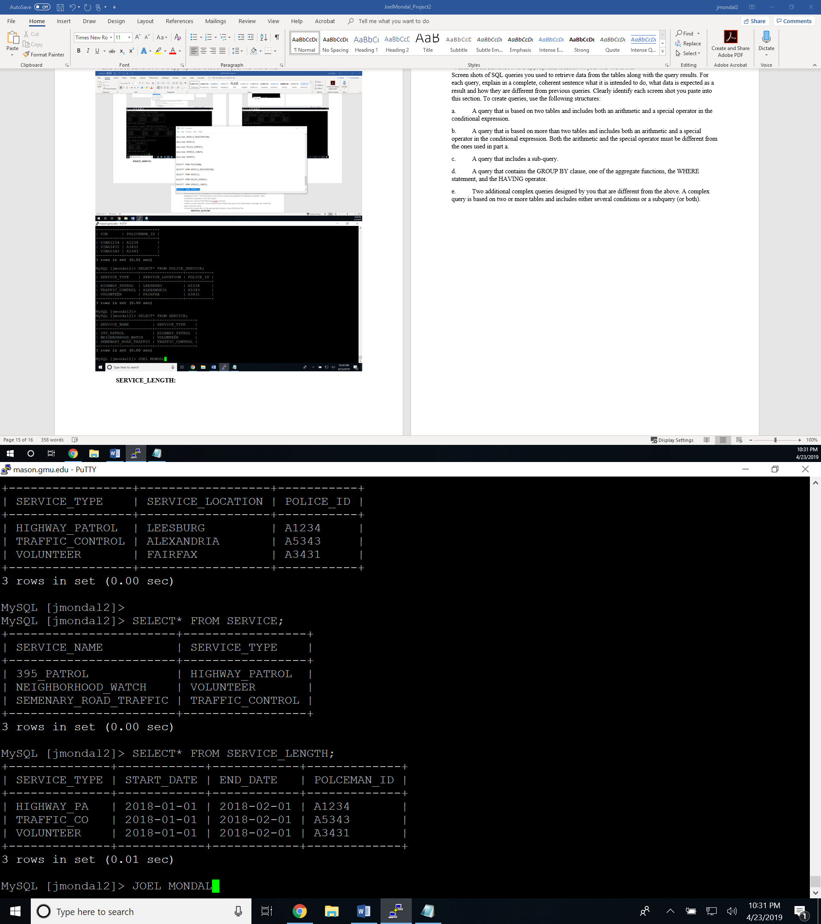

Screen shots of SQL queries you used to retrieve data from the tables along with the query results. For each query, explain in a complete, coherent sentence what it is intended to do, what data is expected as a result and how they are different from previous queries. Clearly identify each screen shot you paste into this section. To create queries, use the following structures:

1. A query that is based on two tables and includes both an arithmetic and a special operator in the conditional expression.

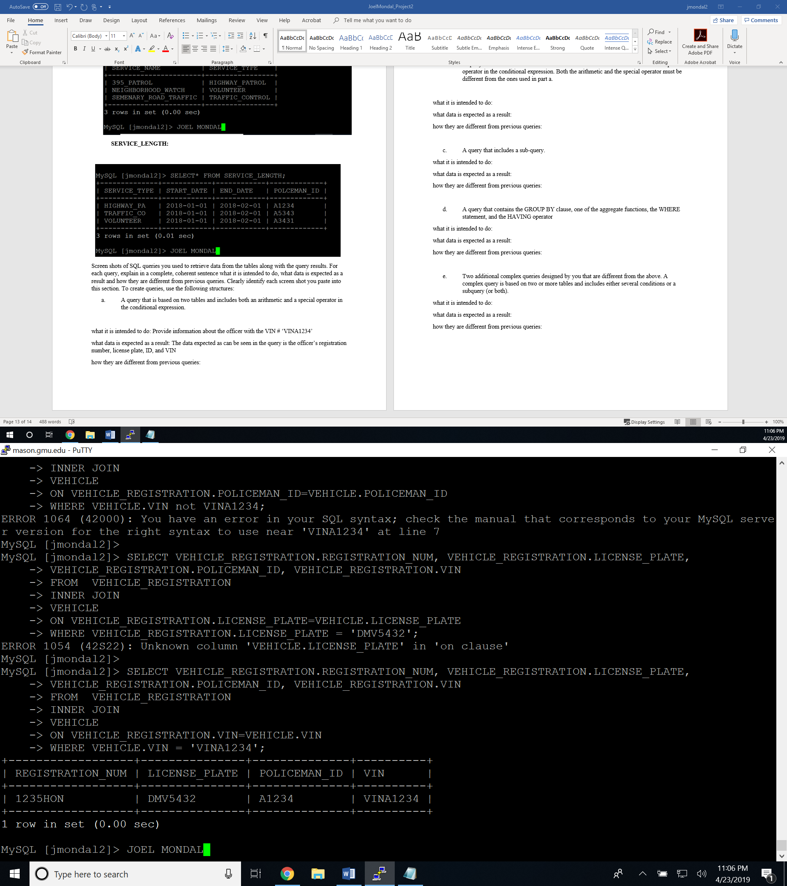

what it is intended to do: Provide information about the officer with the VIN # ‘VINA1234’

what data is expected as a result: The data expected as can be seen in the query is the officer’s registration number, license plate, ID, and VIN

how they are different from previous queries: Uses equals operator

1. A query that is based on more than two tables and includes both an arithmetic and a special operator in the conditional expression. Both the arithmetic and the special operator must be different from the ones used in part a.

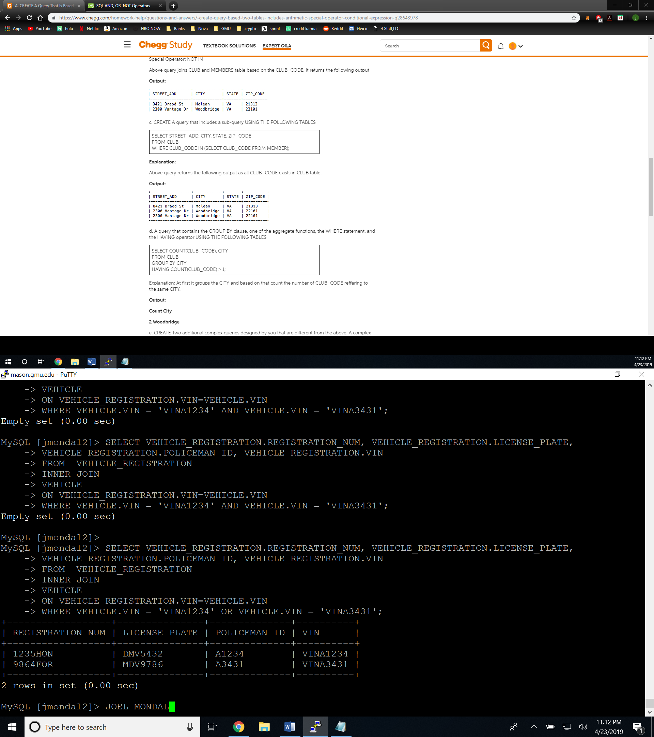

what it is intended to do: Provide information about the officer with the VIN # ‘VINA1234’ or VIN# ‘VINA3431’

what data is expected as a result: The data expected as can be seen in the query is the officer’s registration number, license plate, ID, and VIN

how they are different from previous queries : auses OR operator providing more results

1. A query that includes a sub-query.

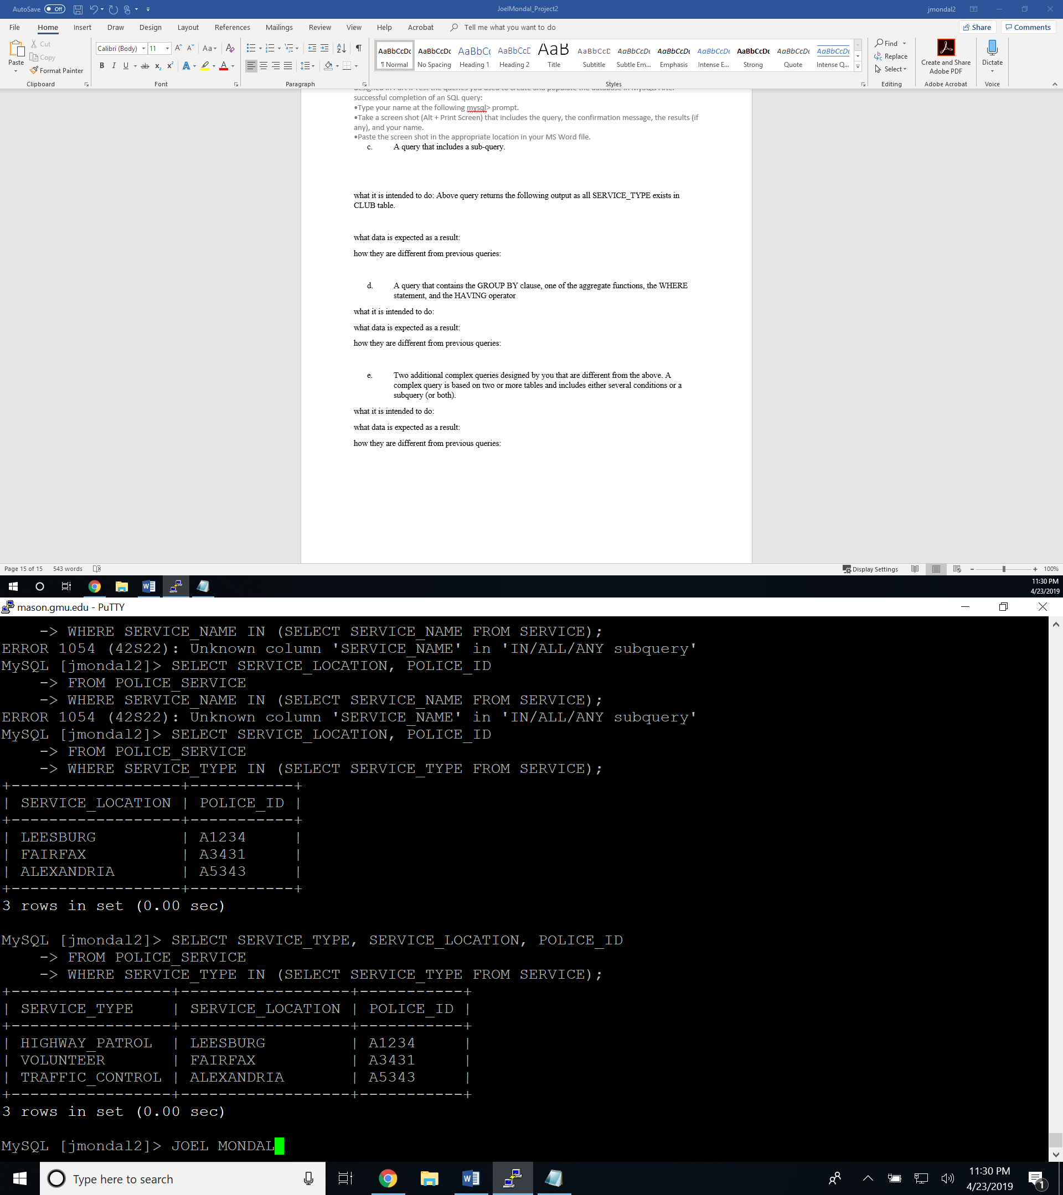

what it is intended to do: Above query returns the following output as all SERVICE_TYPE exists in POLICE_SERVICE table.

what data is expected as a result: SERVIC_TYPE, SERIVCE_LOCATION_POLICE_ID

1. A query that contains the GROUP BY clause, one of the aggregate functions, the WHERE statement, and the HAVING operator

**I had to insert an extra registration number because the date inputted for these tables were not sole integers; they all have a combination of integers and letters. I did not know we would be asked to use a count command otherwise I would have used more integers. Sorry.**

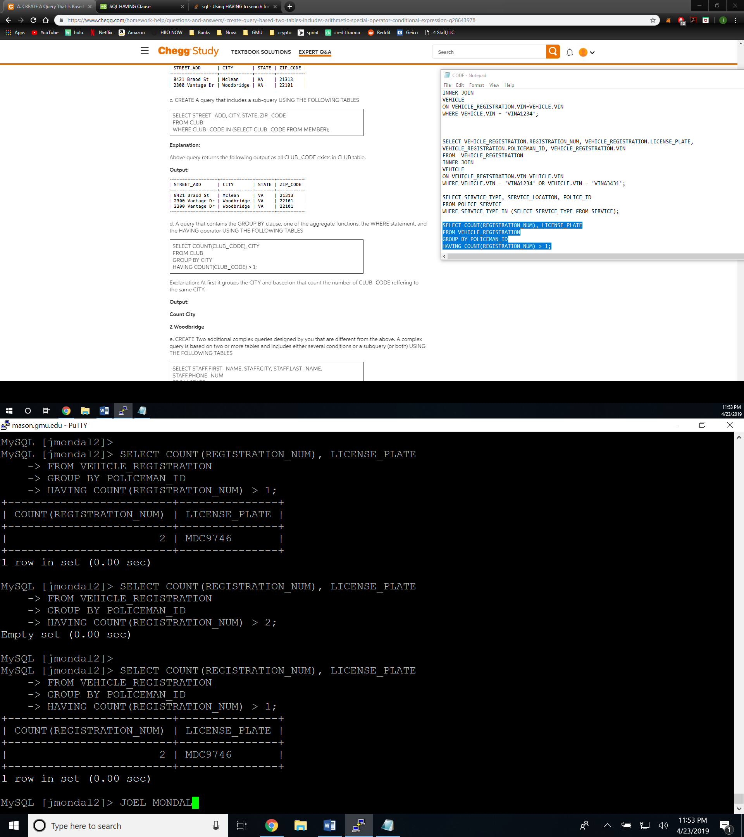

what it is intended to do: counts how many registration numbers are greater than 1

what data is expected as a result: only one license plate should show up because I had to insert the value since the data, I originally inputted for these tables were not sole integers.

how they are different from previous queries: This set of commands uses the count function.